The 1st Saemangeum Cup International Yacht Race 2015
Saemangeum area, Gyeokpo harbor, Korea
Jury 8 to 12
Host: Jeollabuk-do, Buan-gun
Supervised by: Jeonbuk Sailing Federation
Sponsors: Leisure sport and Maritime of Fisheries department
Organizing Authority: Saemangeum Cup Yacht Race Organizing Committee
ORGANIZING AUTHORITY
The 1st Saemangeum Cup International Yacht Race 2015 is organized by the Saemangeum Cup Organizing committee in conjunction with and : Jeonbuk Sailing Federation.
NOTICE OF RACE
1. RULES
1.1 The regatta will be governed by the ‘rules’ as defined in The Racing Rules of Sailing 2013-2016.
1.2 The regatta rules are followed by:
a) The ORC rules will apply to the ORC Club Class.
b) KSAF PHRF Rules will apply for OPEN class.
1.3 The following prescriptions of national authority rule 2 will apply.
(If an incident results damage or injury that is obvious to the boats involved, the boat found to have breached rule by the protest committee shall be responsible and compensate for it. However, the protest committee may decide proportion of necessity.)
1.4 If there is a conflict between NOR and SI, SI will take precedence. This changes RRS 63.7.
1.5 If there is a conflict between languages the English text will take precedence.

2. ADVERTISING
2.1 ISAF Advertising Code will apply.
2.2 A boat shall display the bow numbers with advertisement, stay flags and other advertisement provided and instructed by the Organizing Authority in accordance with this Notice of Race and the Sailing Instruction.
2.3 The Organizing Authority may also require the installation, at no cost to competitors, of on board video cameras, positioning devices, and guest riders. Failure to carry and operate a positioning device or to carry a camera when required will lead to rejection of an entry, the cancellation of an entry or the disqualification of the boat from the race (refer RRS 76.1).

3. ELIGIBILITY
3.1 Eligibility of Boats for the Keel boat Race
a) Maximum 30 boats will be eligible to compete in the order of registration. Total Number of Korean Boats may be limited to 20 at the maximum.
b) General requirements
A boat shall:
- be single mono hulled and self-righting that have an overall length (LOA) not less than 8 meters
- have a crew that satisfies the requirements of NOR 3.2.
- comply with ISAF Offshore Special Regulations for Category 4.
- be restricted participation of the race cause of slow performance by the Organizing Authority (ORC Rating GPH will apply)
c) Each Korean boat shall be registered to the KSAF yacht registration system on the following website. http://ksaf.org/community/yacht/search/
d) Each Korean boat shall be certified (Administration, Inspection, Insurance etc.) by Korean Boat related Law.
e) Eligibility of ORC boats
- A boat may only be entered in the ORC class if the boat:
has a current year(2015), valid ORC certificate; and
complies with all of the current ORC Rating System Rules, save to the extent they are specifically amended or excluded in this Notice of Race or the Sailing Instructions (refer RRS 78.1).
f) Eligibility of Safety Inspection All participated boats are complied with ISAF Offshore Special Regulations Category 4 for safety inspection. A valid safety certification by inspector will be required for all participated boats. A Safety Check List (attached NOR) will be completed and signed by skipper or boat’s owner, and return with entry form to Organizing Committee.
3.2 Eligibility of Crews for the Keel boat Race
a) The minimum number of crews including skipper on a boat is 5.
b) The age of the person in charge on a boat shall be not less than 21 years old.
c) A Korean crew shall be registered competitor to Korea Sailing Federation. The competitor registration is renewed yearly basis and can be made at the following website.
http://pinfo.sports.or.kr/servlets/player/Index.
4. ENTRY
4.1 Eligible boats may enter by completing the attached entry form and sending the following documents until 10th June 2015. Dates and times are Korean Standard Time. (UTC +9)
a) Completed and signed official entry form.
b) Entry fee payment confirmation.
c) Current ORC Certificate.
d) Picture of Team, Skipper and boat.
e) Photo of the boat in hi-res JPEG.
f) Certificate of insurance.
g) Team logo in JPEG.

4.2 Over entries may be accepted at organizer's discretion.

5. FEES
5.1 Entry fees are given as followed.
Entry | Before 10th June 2015 | After 10th June 2015
Fee for a boat | 200,000won | 300,000won
Fee for members | 20,000won | 30,000won
[Bank Account Details]
Bank: Nonghyup Bank
Account Name: Jeonbuk Sailing Federation
Account No: 351-0615-7028-03
please write owner’s name of the boat and class
6. REGISTRAION
Each Owner or Skipper shall personally register in the Race Office located at the Kuckpo Harbor as per the following schedule.
* You must hand out the ‘Long distance water leisure activity’ and ‘Certificate of moorage’ form that is provided by the headquarters of cost guard at the registration.
7. SCHEDULE
8th July | 10:00 ~  10:00 ~ 15:00  15:00 ~ 17:00 | Race village open  Registration, Measurement & Safety check/CIQ Operation  Race officers, Volunteer safety meeting
9th July | 10:00 ~ 15:00  15:00 ~ 17:00 | Registration, Measurement & Safety check/CIQ Operation  Race officers , Volunteer safety meeting
10th July | 10:00 ~ 12:00  11:00 ~ 12:00  14:00 ~ 16:00  18:00 ~ | Registration, Measurement & Safety check/CIQ Operation  Skipper meeting  Pro-Am Race (Inshore 1st,2nd race)  Opening Ceremony/International Night/Prize giving for Pro-Am
11th July | 10:00 ~ 11:00  11:00 ~ 11:30  11:30 ~  19:00 ~ | Skipper Meeting  On the water parade  1st Day of Race(Inshore 1st,2nd,3rd races)  International Night
12th July | 10:00 ~ 11:00  11:00 ~  19:00 ~ | Skipper Meeting  2nd Day of Race(Inshore 4th race/Offshore 5th race)  Prize Giving Ceremony & Farewell Party

8. MEASUREMENT
8.1 A boat or equipment may be inspected at any time for compliance with certificates, KSAF PHRF class rules, special regulations, Notice of Race and sailing instructions.
8.2 Safety inspection period is 8th July~ 10th July 2015, and an inspector or race committee will contact the participated boat’s owner or skipper individually for inspection place, date and time.
9. SAILING INSTRUTIONS
Sailing Instructions will be available for each entrant at completion of the registration formalities at the venue.
10. VENUE
Attachment 3 shows the location of the regatta areas.
11. RACING AREA AND THE COURSES
The diagrams in Attachment 4 show the racing areas, courses, including the approximate distance between the legs.
12. SCORING
Race results will be determined by corrected times calculated by ORC.

13. INTERNATIONAL JURY
An International Jury appointed according to the RRS Appendix N will supervise the event, and decision of the jury will be final as provided in rule 70.5.

14. SUPPORT VESSEL
All supporting vessel will display official flag which providing by OA.

15. BERTHING
15.1 Boats shall be kept in their assigned places while they are in the harbor.
15.2 OA open boat berth for free for boat coming from other port from 20th June to 19th July.

16. HAUL-OUT RESTRICTIONS
Keelboats shall not be hauled out during the regatta except with and according to the terms of prior written permission of the race committee.

17. COMMUNICATION
Boats shall maintain a 24 hour listening watch for the duration of their race on the VHF Channel assigned by the Organizing Authority.

18. PRIZES
18. 1 The Prize for 1st-3rd Trophy and prize money will be awarded.
18. 2 The Prize for 4th and 5th prize money will be awarded.
18. 3.The first finish will be awarded Trophy.
18 .4 General Rule
a) Income tax will be deducted as per tax agreement between Korea and the recipient’s country. (4.4%for Korean)
b) All prize money will wire on account within 10day after race finish.
c) Either skipper or ship-owner will received all prize amounts at once. d) The prize amount on the following prize chart may be changed in case of any changes
on the Budget Plan of the Race
18.5 Prize Money Table
ORC |  | OPEN |  | Non official Prize
 |  |  |  | Pro-Am Race |  |  |  | Opening Parade
 |  |  |  | ORC |  | OPEN
Place | Prize | Place | Prize | Place | Prize | Place | Prize | Place | Prize
1 | 4,000/Trophy | 1 | 3,000/Trophy | 1 | 500 | 1 | 500 | 1 | 500
2 | 3,000/Trophy | 2 | 2,000/Trophy
 |  |  |  | 2 | 300 | 2 | 300 | 2 | 300
3 | 2,000/Trophy | 3 | 1,000/Trophy
4 | 1,000 | 4 | 800
 |  |  |  | 3 | 200 | 3 | 200 | 3 | 200
5 | 500 | 5 | 400
Total | 10,500 | Total | 7,200 | Total | 1,000 | Total | 1,000 | Total | 1,000
Unite (1000won)
19. SUBSIDY SUPPORT
19.1 Subsidy support for boat are as follow
(a)Sailing the boat and shipping on land are same support.
(b) Korean boat; Income tax will be deducted
(c) Non Korean boat: Income tax will be deducted as per tax agreement between Korea and the recipient’s country.
19.2 Subsidy is as follow
category |  | Departure Port | Money (KRW)
 |  | Departure Port | Up to LOA 8 meters | More than LOA 12 meters
Oversea | All Distance are the same | Qingdao, China  Fukuoka, Japan  Vladivostok, Russia | 1,300,000 | 1,500,000
Domestic | More than 300Km | Jeongok, Namhae | 1.000,000 | 1,200,000
Domestic | Less than 100Km | Mokpo, Okcheon | 700,000 | 900,000
Domestic | More than 50Km | Local | 400,000 | 600,000
Distance from departure port to Gyeokpo port
The distance shall be calculated by Organizing Authority.
* You must hand out the ‘Long distance water leisure activity’ and ‘Certificate of moorage’ form that is provided by the headquarters of cost guard for the subsidy support.
OA will support 200,000won for Korean entry which has more than 2 overseas crews.
19.3 Subsidy money will be calculated by the final departure of the boat. If the boat is already in domestic area without the regatta announced date, the subsidy will be calculated as a domestic boat and this apply to same as domestic boats.
19.4 Boats not attending all the schedule of the event by unacceptable reasons and refused to enter the event OA will not getting any subsidy support.
20. SAFETY
Boats entering the Saemangum Cup International Yacht Race shall comply with OSR Category 4.
21. DISCLAMIER OF LIABILITY
Competitors participates in the regatta entirely at their own risk. See rule 4, Decision to Race. The organizing authority will not accept any liability for material damage or personal injury or death sustained in conjunction with or prior to, during, or after the regatta.
22. INSURANCE
Each participating boat to the Saemangum Cup International Yacht Race shall be insured with valid third-party liability insurance or valid Water Leisure Comprehensive Insurance for Korean participating boat.
23. FURTHER INFORMATION
For further information, please contact:
Saemangeum Cup Int’l Yacht Race Organizing Committee / Jeonbuk Sailing Federation
#794-2 Gyeokpo-ri, Byeonsan-myeon, Buan-gun, Jeollabuk-do, Korea
Tel. +82-63-5801005 Fax. +82-63-5800306

Attachment #1
[ENTRY FORM]
The 1st Saemangeum Cup International Yacht Race 2015
- CLASS
- ORC |  |  |  |  |  | - OPEN
- BOAT
Boat name: |  |  | Maker: |  |  |  | Model:
LOA: m |  |  | Beam: m |  |  |  | Draft(including keel): m
Sail Number: |  |  | Home Port: |  |  |  | Estimated arrive date:
- SKIPPER
Name: |  |  | Address:
Nationality: |  |  | Sex: M / W |  |  | Contact Number:
Passport Number: |  |  |  |  |  | e-mail address:
Height: |  |  |  |  |  | Weight: |  |  | T-shirt size:
- Crew List
NO | Name | Nationality |  | Passport | Contact |  |  | e-mail |  | Others
1 |  |  |  |  |  |  |  |  |  | Height(cm):  Weigh(kg): Sex:
2 |  |  |  |  |  |  |  |  |  | Height(cm):  Weigh(kg): Sex:
3 |  |  |  |  |  |  |  |  |  | Height(cm):  Weigh(kg): Sex:
4 |  |  |  |  |  |  |  |  |  | Height(cm):  Weigh(kg): Sex:
5 |  |  |  |  |  |  |  |  |  | Height(cm):  Weigh(kg): Sex:
6 |  |  |  |  |  |  |  |  |  | Height(cm):  Weigh(kg): Sex:
7 |  |  |  |  |  |  |  |  |  | Height(cm):  Weigh(kg): Sex:
8 |  |  |  |  |  |  |  |  |  | Height(cm):  Weigh(kg): Sex:
9 |  |  |  |  |  |  |  |  |  | Height(cm):  Weigh(kg): Sex:
10 |  |  |  |  |  |  |  |  |  | Height(cm):  Weigh(kg): Sex:
- Bank Account Details of the skipper(Remittance of prize money and boat travel support purposes)
Bank: |  |  |  |  | Account Number:
ABA Number: |  |  |  |  | SWIFT code:
Account Name:  (Beneficiary) |  |  |  |  | Other Information
Agreement: I agree to be bound by the ISAF Racing Rules of Sailing 2013-2016 (RRS), the ISAF Offshore Special Regulations 2014-2015, ORC Racing rules and the Notice of Race and Sailing Instructions for the race(s) concerned.
Skipper Name: |  |  |  | Signature: |  |  |  |  | Date:
Attachment #2
Account details and copy of passport
Copy of Account details
Copy of Passport
Attachment #3
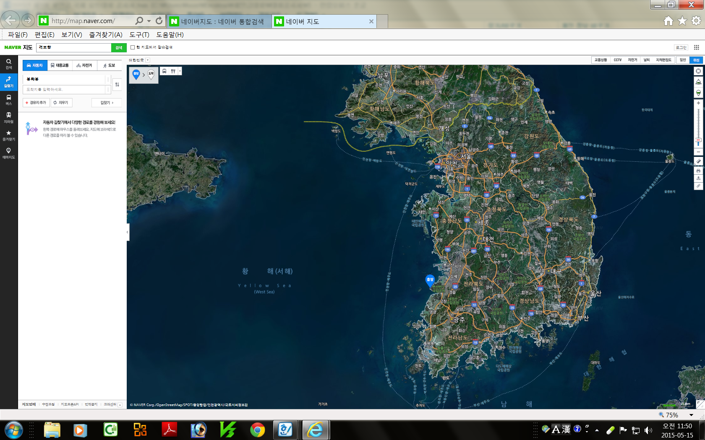
Race Venue

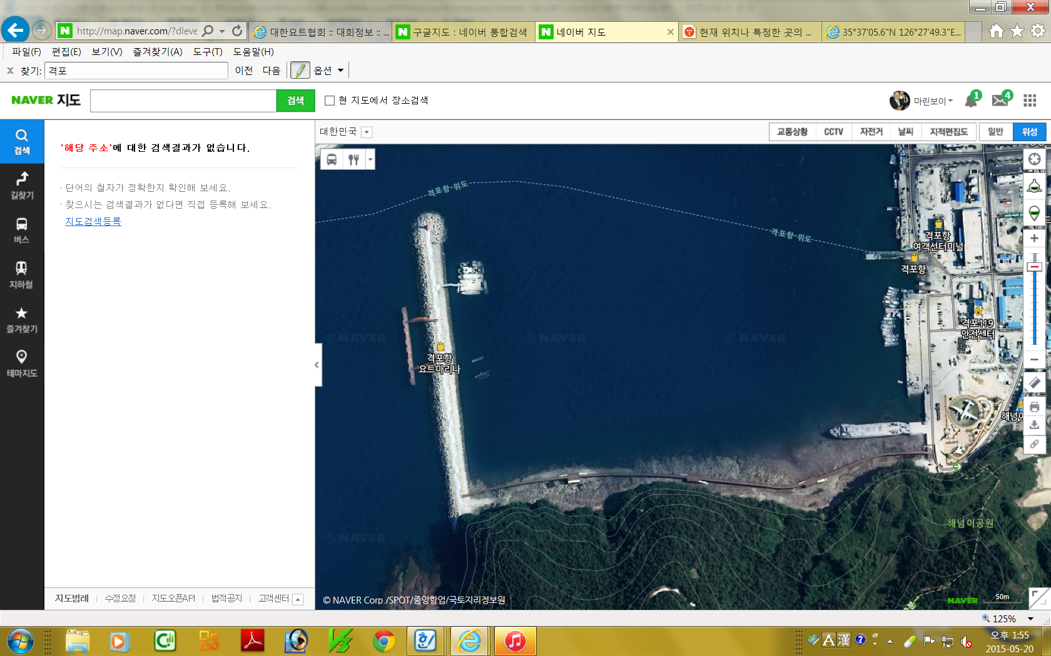
Jeollabuk-do, Saemangeum (Gyeokpo port, Saemangeum breakwater)
Event Hall Office

Race Office

Mooring
Area
Gyeokpo Harbor

Attachment #4
Racing Area and the Course
OFFSHORE:
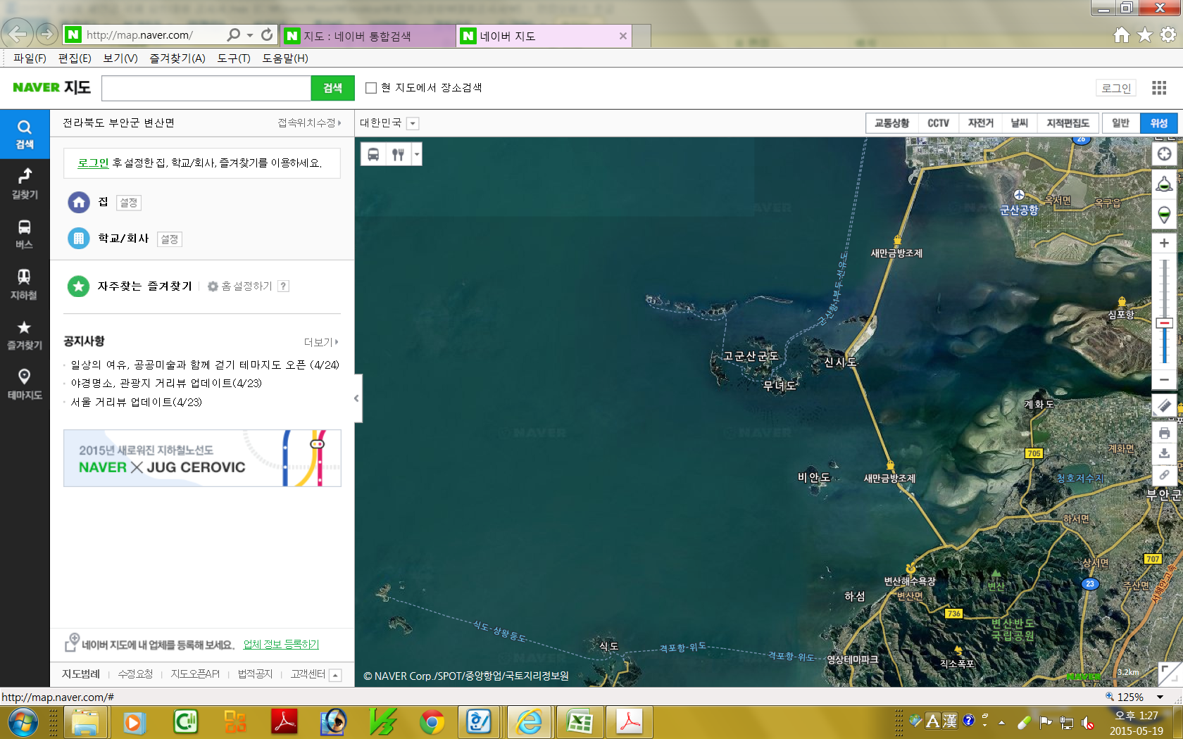

INSHORE
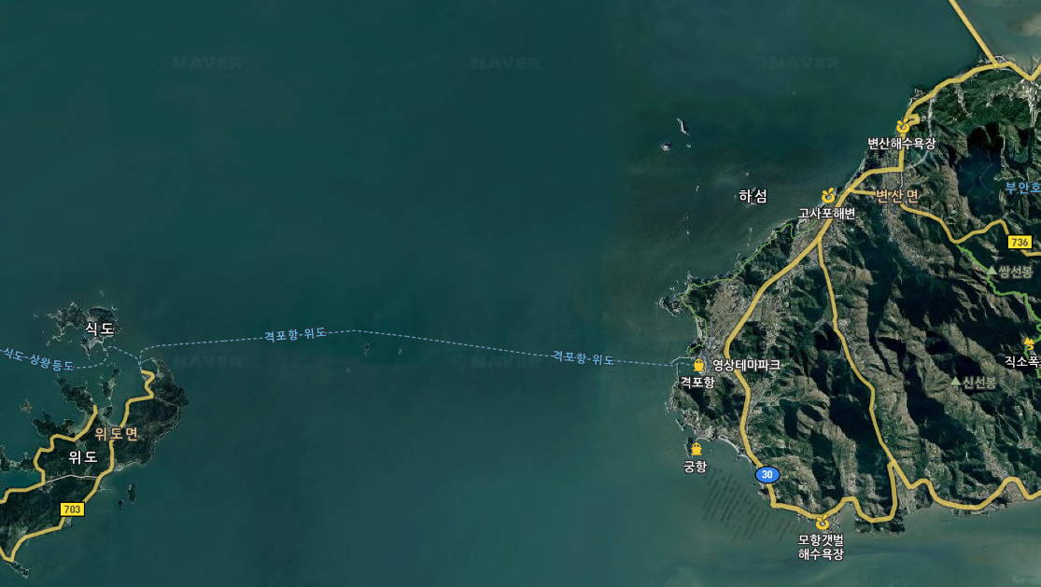

Coordinate of Major points
Jeonbuk, Gyeokpo Port  Venue for registration and race office  ▪Add:  Jeonbuk, Buann-gun, Gyeokpo- ri, Gyeokpo port, Korea  ▪coordinate:  35°37'05.6"N 126°27'49.3"E  (west breakwater) | 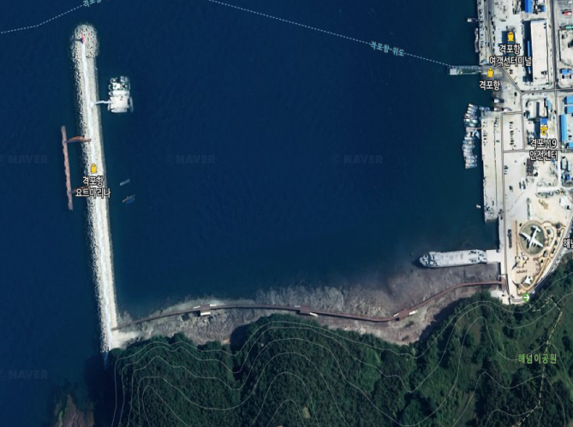  Race Office OfficeOffice

